Newsletter Issue 15: Autumn/Winter 2023 - 2024

Chair’s Welcome
Hello everyone, and welcome to the Autumn 2023 edition of the Nottingham Women’s History Group newsletter. Whenever I come to review our activity, I’m always pleasantly surprised by the number of events we’ve led or participated in since our previous edition, and the last 6 months or so are no exception.
We held three walks on summer evenings – Women Authors; Nurses, Nuns and Notables; and Plaques for Women – all of which attracted respectable numbers of participants, and we plan to offer them on weekend afternoons in 2024 to allow more people to attend.
September and October have both been busy months. As well as talks to organisations as diverse as Nottingham City WI and the Women’s Network of Nottinghamshire Fire and Rescue Service (that was an exciting one!), we met the lovely Year 4 pupils of Robert Shaw Primary School who once again kept us on our toes with their knowledge of and questions about suffragettes and their fight for the vote. We also held an

extremely well attended event at Bromley House Library where we read and discussed the poems of lacerunner Mary Bailey. If you couldn’t make it, we’d definitely recommend getting the book from Five Leaves to read these remarkably articulate, witty and poignant poems for yourself.
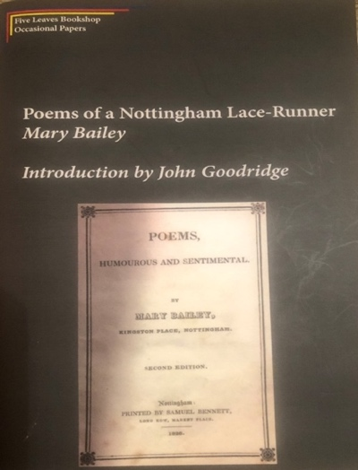
We’ve taken our display to several history events to remind people that women made history too! In May we went to the Great Nottinghamshire Local History Fair, now rebranded Hands on Heritage Day. September found us with a stall at Beeston and District Civic Society’s heritage open days event; and in October we attended the University of Nottingham’s History Fair.

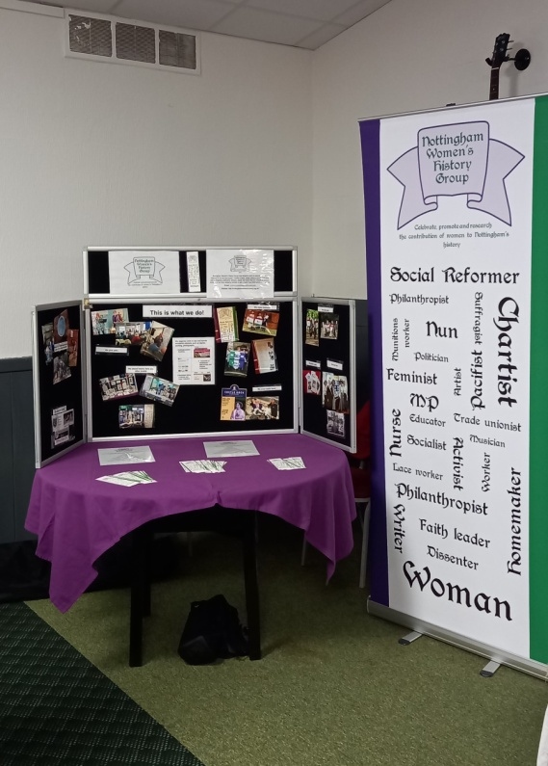

The next six months promise to be just as busy with talks for other organisations as well as for you, our lovely members and loyal supporters, but we’ll keep you informed about all our plans, and look forward to seeing you whenever you can make it.
Sian Trafford

More Notable Nottingham Women
I visited the London Metropolitan Archives (LMA) to see their Unforgotten Lives exhibition and came across Lorna Holder, who I’ve added to my list of Notables.

Lorna Holder 1952 – Fashion Designer

Lorna was born in St Thomas in Jamaica and came to Nottingham in 1959, when she was 7, to join her parents. From 1970-72 she studied at Derby Art College and then at Trent Polytechnic from 1972-1975. She was the first woman of colour to graduate in fashion with a BA honours. She went on to work at Mono in London who produced high quality ladies’ coats and suits for Harrods and Selfridges.

In 1979 she began work for Davies & Field, a ladies’ dress manufacturer as head of young fashion. She assembled her own team of designers, pattern cutters and machinists. Lorna created designs for major chain stores, e.g., Littlewoods, Lady at Lord John, and the Oxford Street Dept. Store Bourne & Hollingworth. In 1986 she left Davies & Field and with her husband set up a retail hairdressing and beauty salon called Lapaz in Camden and in Kensington & Chelsea. Later in 1990 she created Lorna Holder Couture, designing unique clothing for wealthy clients, advertising in Vogue and Bride.
She was the Executive Producer for the first Black Film and TV Awards held at Grosvenor House in 2002. She has delivered 6 Heritage Lottery Fund (HLF) productions based on research and oral histories of Caribbean people and other communities in the UK and has collaborated with the V&A, British Museum, Rich Mix, BFI, Nottingham Theatre Royal and London Metropolitan archives.

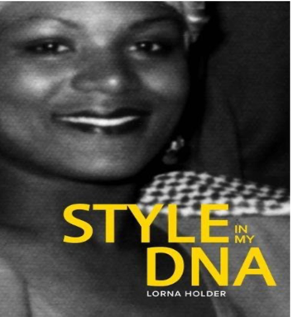

In 2018 she wrote Style in My DNA documenting 70 years of British Caribbean fashion. She is Associate Producer for Nine Nights selected for the Pan African film festival in Los Angeles in 2019. She is Managing Director of Full Spectrum Productions, a not-for-profit company working in the arts on community educational and heritage funded projects including Jamaica Hidden Histories; and also of Tuareg Productions. She is a Governor of NTU Board. Her business archives are held at LMA and her British Caribbean photo collection at the Mary Evans Picture Agency, LMA/4660.
Miriam Jackson

You can find an interview with Lorna Holder following the publication of Style in my DNA on YouTube: https://www.youtube.com/watch?v=ysE4uVVXxe4

Trip to Serbia to Honour My Great Grandfather Lance Corporal Thomas Bexton, Elsie Inglis and the Scottish Women’s Hospital
When I was 12 years old my grandma showed me photographs of her father Lance Corporal Thomas Bexton -M2/076388 – M.T.COY – Royal Army Service Corps. When WW1 had ended, he volunteered to help Serbian refugees across a river, caught Typhus Fever and died on 24th February 1919. Two days after his wife’s birthday and two days before he was due to come home.

Tragically his nurse, Agnes Kerr Earl, of the Scottish Women’s Hospital cut her finger, developed sepsis and died on 19th March 1919. She was buried in the grave next to my Great Grandfather. My Grandma had wanted to put flowers on his grave and never had the chance. I promised I would one day lay flowers for her.

40 years on I honoured that promise in June 2015 when I visited Chela Kula Military Cemetery, Nis, Serbia. He had been moved, as his nurse was no longer next to him.

When I came back to the UK, I did some research and found he had died in Vranje, Serbia. I wanted to go back and complete my journey to honour him. This happened on September 13th 2023, the 4th anniversary of my mother’s death. Nottingham Women’s History Group forwarded an email from an interested party in Edinburgh enquiring if anyone wanted to go to Serbia to honour The Scottish Women’s Hospital and raise awareness and funds for a statue of Dr Elsie Inglis, Suffragist and founder of SWH on the Royal Mile in Edinburgh. I said I would have gone but they were not going to Vranje. Three days later they had changed the itinerary to include Vranje.

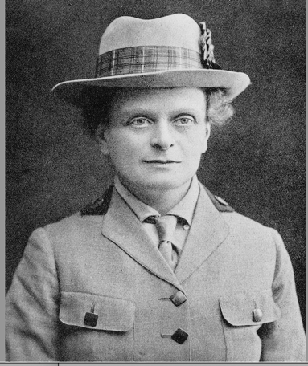
Elsie Ingliss
https://wellcomeimages.org/indexplus/image/M0017817.html

The ex-military attaché to the British Ambassador in Serbia, Nick, obtained permission from the MOD to accompany us. Due to his contacts, we had a reception at the British Embassy, went to the Royal Palace expecting to be shown round, but the Crown Prince and Princess gave us afternoon tea and nibbles. I discovered the hospital where my Great Grandfather died was still there, it is an army barracks, and took photographs (I was not meant to).

We had a civic reception at Vranje at the Dr Isobel Emslie Hutton Teaching Hospital! No one knew this was happening. Serbian TV interviewed me twice and I appeared on Women’s Hour live from Serbia. Then we travelled on to Nis. The man who looks after the war graves had kept the laminated photograph I had placed on Great Grandfather’s grave 8 years ago. His father had the job before him and told him, ‘You must protect the 5 nurses buried there’. All the staff from the SWH are honoured in Serbia, monuments and memorials are to be found everywhere and they hold annual commemorative ceremonies.

This trip should have taken place in 2020, but Covid delayed it, otherwise I would not have known about it. There have been so many coincidences that enabled me to join this trip, which allowed me to have the most moving experience possible. Dr Iram Qureshi and her daughter Hareem are making a feature film about Dr Elsie Inglis, and a documentary about our trip to Serbia and all the intrepid women who went with us.
Carole Ann Powell

You can find out more about nurse Agnes Kerr Earl on Cumnock History Group’s 2014 blog posts Nurse Agnes Kerr Earl and More on Sister Earl: https://cumnocksoldiers.blogspot.com/2014/03/nurse-agnes-kerr-earl.html

A Woman’s Place - Ruth Adam, Nottingham Author, 1907-1977
My childhood was spent in draughty Vicarages, where ends never quite met. And I knew, ever since I could remember, that my mother had been brought up in a different kind of house – with a drive sweeping up to a pillared door, where great trees stood sentinel. I knew, from occasional visits to my grandfather, how there was a dairy with slate slabs next to the harness-room, with its smell of saddle-soap, and also how the household moved to a measured routine, like the figures of an old-fashioned dance. My mother had married a penniless curate and annoyed her family even more by being blissfully and unrepentedly happy with him.
(A House in the Country)

Feminist, author and teacher, mostly remembered for an early history of the modern women’s movement, A Woman’s Place: 1910-1975, Ruth Augusta King was born in Arnold, the second daughter of the Reverend Rupert King and his wife, Annie. She was educated at St Elphin’s, the school for daughters of the clergy near Matlock. She left at eighteen and without any further training began work as an elementary teacher.

King taught for several years in deprived mining communities of Nottingham and her first novel, I’m Not Complaining (1938), is based on her teaching experiences during the Depression in an area she calls ‘Bronton’. The narrator, Madge Brigson, observes the daily mess of humanity in both Upper and Lower Bronton with an affectionate but unsentimental eye. Staff room tensions erupt into violence and elderly teachers struggle to hide their domestic woes whilst attempting to support chaotic families broken down by poverty and unemployment. But there is humour, too, and a frank insight into the lives of women teachers in the ‘twenties and ‘thirties.

In 1935 Ruth King married local boy Kenneth Adam who was to become Controller of the Light Programme and later Director of Television for the BBC. Towards the end of the war, they, and a group of friends, became obsessed with the idea of living in a country house:
“After dinner, in the evenings,” said Diana. “We shall all sit round in the old drawing room, with the French windows open and night-scented stock in the flower-bed outside, and sip our coffee.” Diana thought most about this, because she hated queuing for spam in a smoky restaurant... (A House in the Country)

The reality was very different: A House in the Country (1957) is the story of eight years spent in a dilapidated 33-room house in Harpenden which finally beat the inhabitants into submission. Funny, poignant and wise-after-the-event, the book is evidence of a changing social climate in Middle England after WW2 and an experiment in communal living which was a few years ahead of its time.

Ruth Adam wrote ten novels for adults and older children, many with a ‘social’ theme. She also wrote essays, radio plays, and a biography of Beatrice Webb co-authored with Kitty Muggeridge (1967).

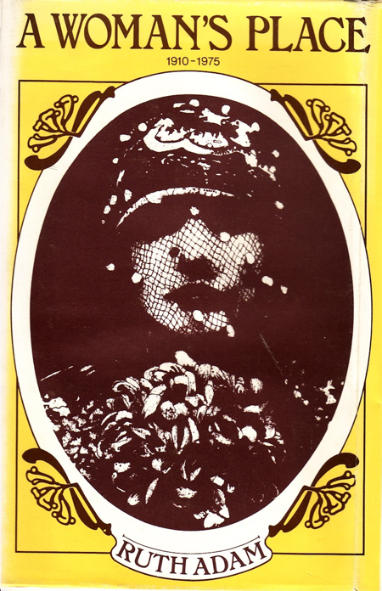

Sadly, most of her books are now out of print, but I’m Not Complaining was republished by Virago Classics in 1983 and is worth searching for, and her last book, A Woman’s Place: 1910-1975, is available from Persephone Books in an elegant edition.
©Rowena Edlin-White
Author’s Note: a version of this article appeared in The Southwell Folio in 2012.

Mary Bailey’s Poems
On 6th September NWHG were pleased to be hosted by Bromley House library and held a session focused on Five Leaves’ recently published edition of Mary Bailey’s poems. Mary a poorly paid working woman with some 8 or 9 surviving children lived in Sneinton and in 1826 published a slim volume of 13 poems. She published the volume by subscription hoping to make some money to supplement her meagre income.

Some 40 people came along to the session to learn what little we know of Mary’s life and to hear some of her poems, to stimulate discussion. There was much speculation about her life – was she born into a more middleclass family where she had learned to read and write and to read and write poetry? Had she fallen on hard times by virtue of her marriage and children? Her obituary records that she had been a lady’s maid, a role normally reserved for a better class of young woman with the role of house maid being a more likely one for a working-class girl.

Or was she from a working-class background but had nevertheless learned to read and write striving to educate herself perhaps at a Sunday school? Did she write as a form of therapy? To help her deal with her problems or was she simply determined to speak out about the abuse she and others suffered - and so had been determined to have her voice heard.

Was she a radical working-class woman a friend perhaps of Susannah Wright (see last Newsletter) a former lace worker and a contemporary who opened a radical bookshop in Goose Gate in 1826. Sadly, we will never know but it was interesting to share people’s ideas about her life and to be challenged to think more broadly about her writing.

Her poems describe her role as a lace runner or embroiderer and how hard her life was with long hours, poor wages and the constant threat of hunger for her and her children. We recognised that unfortunately very little has changed with garment workers in today’s fast fashion world being exploited, insecure and poorly remunerated just as Mary was back in the early 1800’s.

It was an enjoyable and stimulating afternoon and it was exciting when immediately afterwards someone got in touch having found Mary’s burial record at St Mary’s church, at age 42 giving us a birth year of 1786 - something which hadn’t previously been known. Maybe more will be found!

Many thanks to Bromley House – we hope to repeat the session again with a focus on another largely forgotten Nottingham woman writer.
Miriam Jackson

Lord Byron & the Ladies of Burgage Manor

In 1832 Caroline Berdmore Fowler moved into Burgage Manor, the elegant house that had, briefly, been home to the poet Lord Byron and his mother Catherine from 1803 to 1808.

Caroline was the only child of the Rev Charles Fowler and his first wife Charlotte Greaves; although she had several half siblings, the children of her father and his second wife, Harriet Hacket. Caroline was independently wealthy, inheriting part of the fortune of her mother’s uncle, Thomas Berdmore; the dental surgeon who numbered George III amongst his patients and is commemorated in St Mary’s, Nottingham.

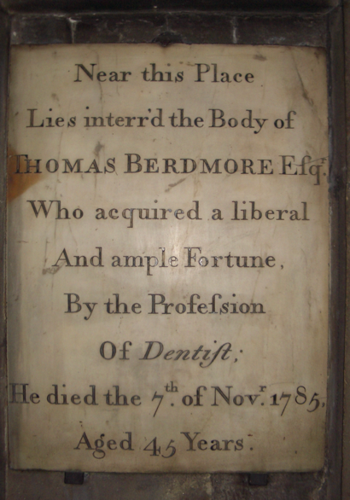

Memorial to Thomas Berdmore
By Andrewrabbott (talk) – Own Work (Original text: self made), Public Domain

Caroline lived at Burgage Manor with Marianne Bristoe, the only daughter and heir of the Rev William Bristoe, vicar at Upton. Both Caroline and Marianne remained unmarried and the terms of their Wills strongly suggest they had a loving relationship. Their independence meant they were able to afford to run Burgage Manor with several, mostly female servants.

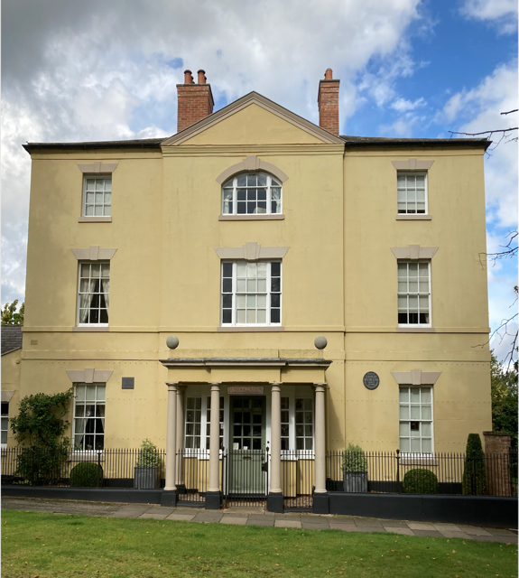
Burgage Manor, Southwell

Sharing his home was not the only connection the women had to the notorious poet. In 1806 Byron took part in some private theatricals in the home of Mr Leacroft; indeed, Byron appears to have been the driving force behind the adventure. Two plays were performed: The Wheel of Fortune by Richard Cumberland and John Till Allingham’s The Weathercock. Appearing in the cast of both was Miss Marianne Bristoe.

Marianne wrote a detailed account of the theatricals, in which she had leading roles opposite Byron and, although eight years his senior, she appears to have developed a crush on him. This is understandable given the racy reputation of private theatricals so vividly described by Jane Austen in Mansfield Park (1814) where The Wheel of Fortune is one of the plays rejected by the Bertram family as unsuitable for their theatricals.

Subsequently Byron heard gossip that he had proposed to Marianne, a rumour that his friend Elizabeth Pigot thought had been spread by Marianne herself. In retaliation Byron wrote three poems which deride poor Marianne as an unattractive old maid. One, Prim Mary Ann, is particularly cruel, recounting the entire affair in a parody upon Henry Bunbury’s The Little Grey Man.

There is no attempt to disguise the poem’s subject and Elizabeth Pigot recalled that, ‘It is a true tale, even the description of the lady’s dress being accurate’.

Byron describes Marianne wearing a red spotted gown under a velvet lined pelisse, a purple bonnet, blue stockings and pea green shoes. She wore her stays tightly laced and had a stately carriage.

As for her personality, she was ‘the plague of her fellows by day & by Night, unsurpassed in her prudish demeanour.

Her dark sparkling Eyes a gay boldness bedecked,
But a stiff Education their glances had checked.

Marianne would have agreed Byron was ‘dangerous to know’.

The poem is too long to reproduce here in its entirety but you can read it in Willis W Pratt’s Byron at Southwell, pages 54 – 59, available on the internet archive: https://archive.org/details/byronatsouthwell0000will_o0o5

Marianne’s account of the theatricals can be found in chapter three of Megan Boyes’ Love Without Wings.
Karen Winyard

Dates For Your Diary
7 October – 13 January, New Art Exchange – Dellu by Enam Gwewonyo, winner of the NAE Open 2022 Exhibition Prize https://www.nae.org.uk/whats-on/category/exhibitions/current/
3-4 November, Nottingham Playhouse – Identities, Co-created with women who have experience of breast cancer and those who treat them. https://nottinghamplayhouse.co.uk/events/identities/
Friday 10 November, Nottingham Contemporary – Being Human Festival; Making a World of My Own: Writing and Experimentation, celebrating the writing of Margaret Cavendish, Ada Lovelace and Lucy Hutchinson https://www.nottinghamcontemporary.org/whats-on/being-human-festival-making-a-world-of-my-own-writing-and-experimentation/
Saturday 11 November, Walk by Notts & Derbys Labour History Society – Working Class Women Organise: events in 19th century Nottingham – led by Roger Tanner. Meet at Nottingham Contemporary at 10.30am – email rogerntanner@yahoo.co.uk to reserve a place. The walk will take about 2 hours and will be on urban pavements.
12-16 March 2024, Nottingham Theatre Royal – Fantastically Great Women Who Changed The World by Kate Pankhurst https://trch.co.uk/whats-on/fantastically-great-women-who-changed-the-world/

Contact Us:

Email: nottmwomenshistory@gmail.com

Website: http://www.nottinghamwomenshistory.org.uk/

Facebook:
https://www.facebook.com/NottinghamWomensHistoryGroup/

Twitter: @NottsWomensHist
If you have something you’d like to send in to the newsletter, please email the editor. We’d love to hear from you.

Contributions to NWHG’s newsletter should be sent to Karen Winyard:
karenwinyard@gmail.com

